

Department | FED
Subject | DSA-2
Academic Year | I-III Semester (2025-26)
Faculty Name | Swetha nagasri
Student Name | Karingula srinivas Kaustav
Roll Number | 2520030617
Branch | CSE
Course Outcome | CO-3
Case Study Topic: Mumbai Distribution Grid — N-1 Redundancy via Bridge Analysis

Work Done Summary:
In this case study, we implemented a graph algorithm solution for Reliance Energy's LV distribution layout planning problem. The network consists of 1 main substation (M)
and 7 distribution substations {A, B, C, D, E, F, G} with 12 candidate underground cable runs. We applied Kruskal's algorithm to compute the Minimum Spanning Tree (MST)
yielding the lowest-cost connected network (19 crore). Since every MST edge is a bridge by definition, we then used
Tarjan's bridge-detection algorithm to identify all 7 bridges.
Finally, we augmented the MST greedily with the cheapest non-MST edges that cover (cycle-close) each bridge, adding 3 edges (A-M, F-G, A-D) at a total augmentation cost of 15 crore,
achieving full N-1 redundancy at a total network cost of 34 crore.

Implementation Details:
- Represented the 8-node, 12-edge graph as an edge list.
- Sorted all edges by cost and applied Kruskal's algorithm with Union-Find to build the MST (7 edges, cost = 19 crore).
- Applied Tarjan's DFS-based bridge detection on the MST — confirmed all 7 MST edges are bridges.
- Identified non-MST candidate edges and determined which MST bridges each one covers via BFS path queries.
- Greedily added the cheapest augmentation edges: A-M (4 cr), F-G (4 cr), A-D (7 cr).
- Verified 0 bridges remain in the final network — N-1 redundancy constraint fully satisfied.

Result: Screenshots / Output

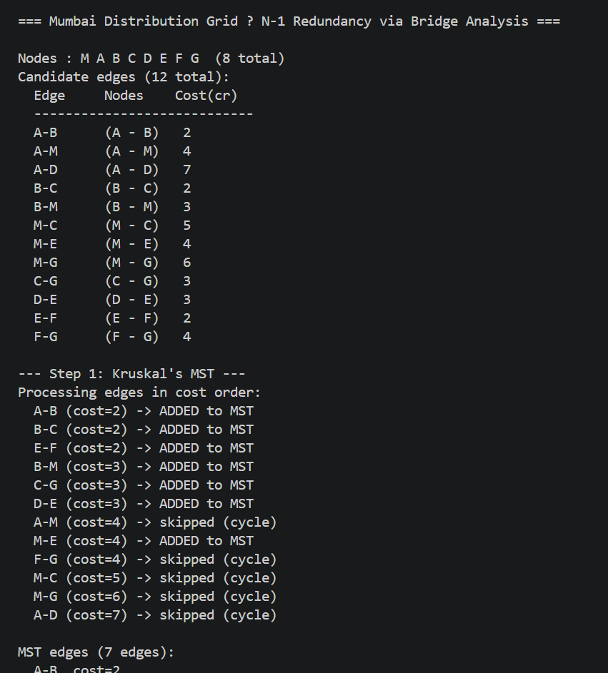

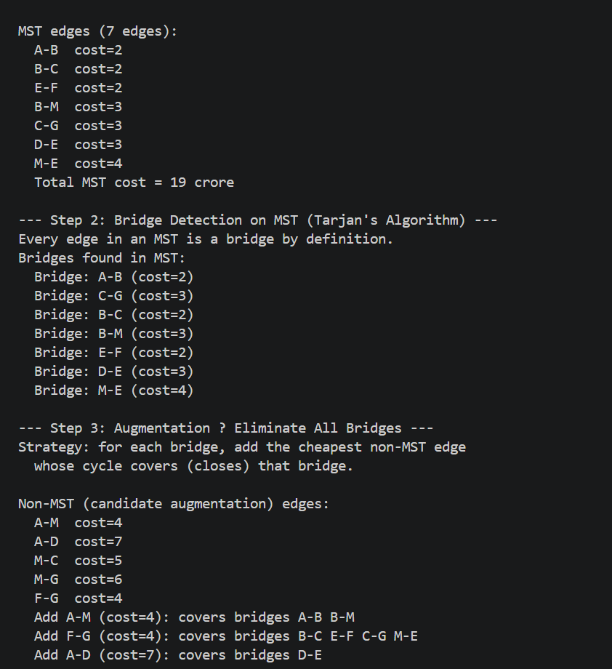

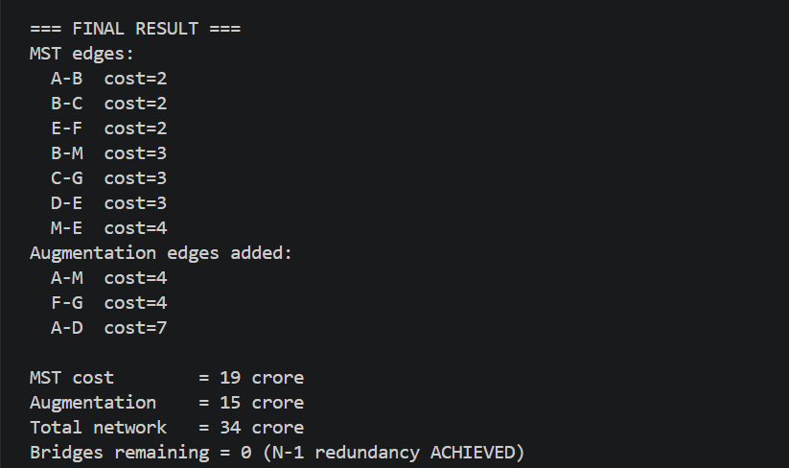

The bridge-analysis approach successfully designed an N-1 redundant distribution network:

Metric | Value
MST edges selected | A-B, B-C, E-F, B-M, C-G, D-E, M-E
MST total cost | 19 crore
Bridges detected | 7 (all MST edges)
Augmentation edges | A-M (4 cr), F-G (4 cr), A-D (7 cr)
Augmentation cost | 15 crore
Total network cost | 34 crore
Bridges remaining | 0 — N-1 Redundancy ACHIEVED

Time Complexity:
  - Kruskal's MST: O(E log E) for sorting + O(E α(V)) for Union-Find ≈ O(E log E)
  - Tarjan's Bridge Detection: O(V + E)
  - BFS Path Queries for Augmentation: O(V + E) per query
  - Overall: O(E log E) — dominated by the sort step

GitHub Link: https://github.com/karingulakaustav-boop/CO3

Student Signature | Faculty Signature

